HCI Supplementary

HOME SUP BUDDY

Mini Design Brief

|  |  |
| --- | --- |
| Name | Student ID |
|  |  |

# Introduction

Nowadays life of a random human being has become somewhat an automated process which does the same exact procedure without having a break through. Therefore, one of the important needs of human being which is food has become no more a need because people doesn’t care about that much until that is required during the busy work life of that person.

Home Sup Buddy is a user-friendly home cook assistant who keeps track of each person’s pantry and the refrigerator supplies and do the online shopping as well as provides what can be cooked out of the available supplies. It works as a kitchen keeper of the house and provides the necessary information regarding each person’s kitchen and food requirements.

## Project Description

This Provides a best user-friendly assistant to keep track of their daily kitchen household needs, shopping and make the best use out of the available. Project target is to minimize the human interference in those household activities and make their lives easier by letting them know everything within a small notification and get what they need with a single touch of their fingertips on a mobile screen.

## Product Scope

Notification Alerts regarding the low availability of the usual supplies. Home Sup Buddy is able to gather the information when supplies are running low using the inbuilt cameras and infrared sensors placed in the kitchen. It has the ability to analyse the basic usage of the daily used products and assume the availability of each of it using the person’s previously gathered data.

Quick daily reminder of the supplies which need to be ordered. After the notification alert pops up on the smart device from the app it keeps sending reminders till the user take an action regarding the notification.

Automatically engage the app alert when going near a client’s store to make aware of the user regarding the low running supplies and missing supplies which need to buy.

Keep track of the daily supplies and try to avoid the unhealthy foods and always it will suggest nutritious supplies instead of those unhealthy useless goods. And the app is able provide food diet information according to the client’s body type and living system.

Provide the best chefs cook book recipes according to the previous preferences is also one of the key features of the scope of the product. It stores and analyse the preferences of the user’s previous food and restaurant searchings and using a simple Machine learning algorithm it can identify the pattern of the preferred food searches and it can give the best recipes regarding the updated available kitchen supplies according to the app.

Ability to Analyse the missing supplies with the Buddy App Camera which is able to scan the pantry and supply store areas and indicate the common supplies which are currently unavailable from their usual spots and the missing percentage of the other supplies which are currently available on the shelves and the counters.

## Audience Details

The most suitable audience is the daily office/labour workers who are fully allocated in any kind of full-time job task and who doesn’t have time to even to think about their personal needs according to the survey. People who live in this kind of stages don’t have much memory regarding all the goods and supplies in the kitchen and keep those remembered also a huge task for them. Therefore, this app is mainly focused on that busy scheduled work life people.

But this app is not limited only to those who are having a full tight life schedule because this provides so much of information to anyone who wants to have some easy process on keeping everything informed and suggested and have the household supplies up to date.

## Usability Objectives

Make it a simple process app which helps any type of users to use the app very easily without having trouble to go through the complex functions and use of the app.

Make easy the busy tight life style of users by providing the necessary household information to their fingertips by giving necessary list of supplies that need to be bought and the quantity without making any misrepresentations. Make Users life easy is one of the main objectives regarding this product.

As well as people tend to eat at home because of the recipe suggestions and the best food types information regarding the available household supplies therefore users stay away from fast food and unhealthy foods which cause health problems.

# Design

## Structural Design

Automatic Notification Alert system which activates according to the user’s location and the time of the day which the user is not in the usual busy tight schedule. Daily morning nutrition summary alert will be popped-up and it provides the daily calorie count and the basic health information.

Reminder alert regarding the supplies which need to order and the currently available supplies in the kitchen to make sure that the user doesn’t run out of supplies until he/she places an order.

Identifying the usual daily supplies and store those items in a fixed cart on the app and keep the track of it according to each item’s basic expiry date and the quantity of the item compared to the daily usage.

Basic Key functions are pre-activated when the app is loaded to the device to help the users to make easy to use it. For an example most of the users who will be using this app are housewives or mid age people. Therefore, having so much of functionalities going to be a problem to handle and maximize the best outcome of the app. Therefore, apart from the basic key functions, other functions can be activated only if the user grant the permission.

Get the user browser history regarding any food or restaurant and analyse it to check the food preferences and the food pattern styles that the user prefers. According to that it will generate a token regarding the best food recipes which can be cooked from the available supplies in the kitchen.

Ability to check the local promotions and any benefits which can be claimed by the user and pop-up it on the notification panel as an offer to user to save something when purchasing from the promotion coupon.

Provide the ability to have a complete supplies menu on the screen and add them into a cart to purchase them through the device and have it to the doorstep on the next day. Unavailable items will be automatically reordered when those become available.

Vuforia Camera function is able connect to the inbuilt refrigerator camera and the pantry planted camera and visualize the daily structure of each places to identify the missing and reduced household objects/supplies and automatically detect it through the saved fixed cart and give a quick reminder of deficit supplies.

## Visual Design

|  |  |  |  |  |
| --- | --- | --- | --- | --- |
|  |  |  |  |  |

Figure 1: Color Pallet

App should be more colourful to attract people to use it more and more. As according to the information regarding households and food supplies, the best colour scheme for food and supplies should contain more on red colour. This has different sections for each function. Main function provides the notification alerts regarding all the household pantry and refrigerator availability and the cook book recipes for the leftover supplies.

As for another functionality it has the best local restaurant food joints which are partnered with the client company.

App notifies the best deals available on the day and the ending soon hot deals are notified every 30 minutes to give the user some reminder regarding that. Shopping can be done through the app therefore the shopping cart is available to list out all the supplies which need to purchase as well as the shopping cart has the ability to keep track on the daily purchased fixed items and it will be automatically added and reviewed to be accepted by the user for the final purchasing.

Figure 2: Adobe XD Design Templates

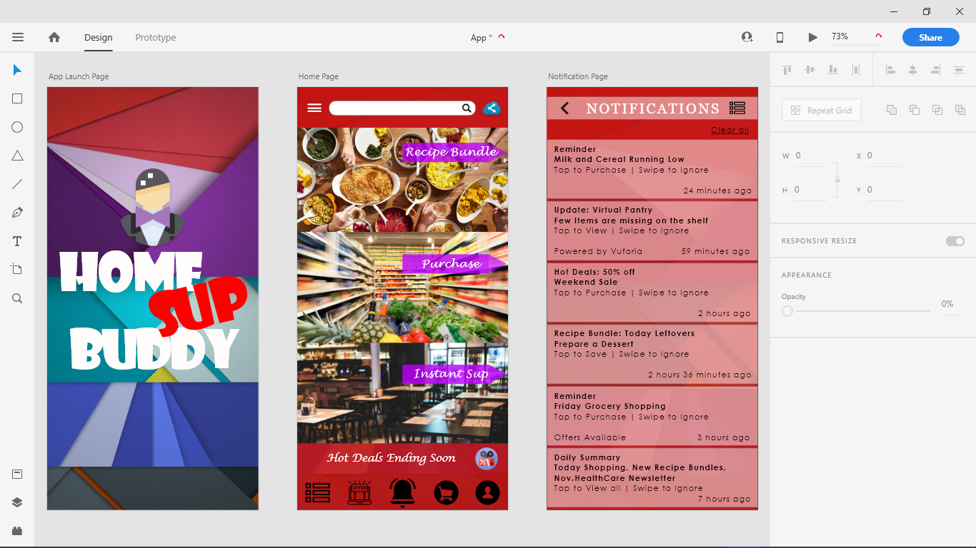

Adobe XD is used to design UX/UI design of the product. Here the Launch Page, Home page and the Notification pages have been prepared with the necessary icons for all the functionalities. This Design is to achieve the maximum customer satisfaction and make it addictive to use daily.

Only three pages have been designed and created up to now. Rest of the pages will be created later.

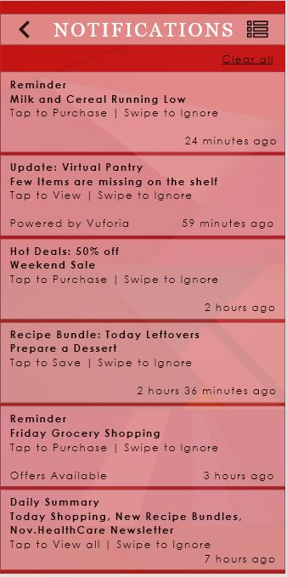

Menu Icon

Figure 4: Notification Page

Figure 3: App Launch Page

Back Icon

All Notification Alert Panel

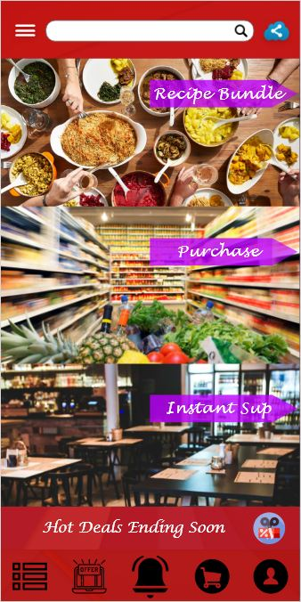

Share Icon

Quick Settings Icon

Search Bar

Recommending Main Bar Panel

Figure 5: Main Menu Page

Main Notification Icon

Ending Soon Offer Widget Icon

User Profile Icon

Shopping Cart Icon

Available All Offers Icon

Menu Icon

## Supporting Design Tools

Figure 6: Survey Form

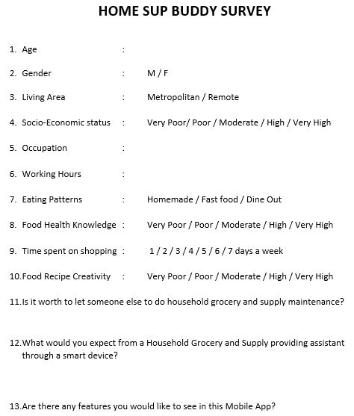

This Survey was done using the parents of the students in our class and captured the best outcome and ideas to create some functionalities used in the home page of the app.

Table 1: Clustered Persona Types

|  |  |  |  |
| --- | --- | --- | --- |
| **Attribute** | **Results** | | |
| **Class 1** | **Class 2** | **Class 3** |
| Age | 45-65 | 45-65 | 45-65 |
| Gender | Female | Female | Male |
| Living Area | Metropolitan | Metropolitan | Metropolitan |
| SES | High | Moderate | Moderate |
| Has an Occupation | Yes | No | Yes |
| Working Hours | 40-50 hours | - | 40-50 hours |
| Eating Patterns | Fast food / Dine Out | Homemade | Fast food / Dine Out |
| Food Health  Knowledge | Moderate | High | Moderate |
| Time spent on shopping | 3 days | 5 days | 3 days |
| Food recipe creativity | Moderate | High | Low |
| Is it Worth to have an assistant | Yes | Yes | Yes |
| Special Requests | Best Prices | Organic Supplies Only Section | - |

These are the achieved personas from the details gathered from the survey. It has three major types showing the three types of main scenarios regarding the Household grocery and food supplies happening in a normal household. This shows the importance of the different functions that needs to add to the app to make the users life much easier.